Tips and tricks for trimming your dog's nails

If you're a pet parent with an aversion to trimming nails, you're not alone! Many people are so reluctant they outsource a groomer or vet. This is fine if you're in a position to make (and pay for) appointments as often as your dog needs her nails trimmed.
However, what often happens is that too much time passes between appointments and nails get uncomfortably long. This can cause injury to the paw. You'd be surprised by how many dogs end up at the vet with paw pain and other problems, which could have been prevented with regular nail trims.
There are several other advantages to learning to trim your dog's nails at home:
- Consistently maintain the nails at a safe length.
- Avoid your dog's "car ride stress" and/or "vet or groomer visit stress."
- Easily comfort her if you see signs of stress and take it slow when necessary, even doing a nail a day if that works best.
Keeping your dog's nails trimmed doesn't have to be a chore, even when you've had a bad experience in the past!
Pets who've developed a phobia about nail trims will require extra time and TLC, but with patience and a pup-friendly approach most dogs can become accustomed to regular nail trims.

Getting Your Dog Comfortable With Nail Trims
Most dogs are uncomfortable with their human "holding hands" with them, which is also the reason they object to having their paws held during nail trims.
Dogs' paw pads are loaded with nerve receptors that help protect them when they walk and run. These receptors also make their paws more sensitive to handling than other parts of their body.
The last thing you want to do is hold your pet down or with an overly firm grip, this can increase the fear level, which can lead to a fight-or-flight response.
Incorporate paw touches into petting. Do this by stroking the head and body then working your way to the paws.
If the only time you touch your dog's feet is to trim her nails, she will immediately know what's coming when you touch her paws.
Another thing to keep in mind is not to rush, you can always go back and take a bit more off but you can't erase the pain memory if you cut one too close.
If you create a painful experience for your dog during nail trims, she'll forever associate trimming with pain.
I recommend the use of food treats, soothing speech and cuddles to create positivity around nail trims.
Also, to start off, only trim one nail a day. Especially if your dog has a very low stress tolerance threshold.
Instead of trying to "get it over with", by doing one nail each day trimming can become a quick and relatively pleasant daily experience for you both and neither of you will become "stressed out!".

Trim enough — but not too much
Regular nail trims are very important! Unlike human nails, the longer you leave dog nails untrimmed the longer the vein inside the nail will grow - making it difficult to keep the nails short. To avoid this from happening it is recommended to trim the nails every couple of weeks, and keep the quick (and nails) nice and short!
Many dogs have dark nails, which are especially tricky because you can't see the pinkish quick, which is the blood vessel inside the nail that nourishes it.
Shine a small flashlight or penlight on dark nails so you can see the quick, which should appear like a black bullseye in the centre of the nail from the front view vs guessing how close you are to it.

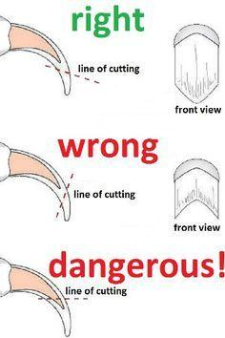
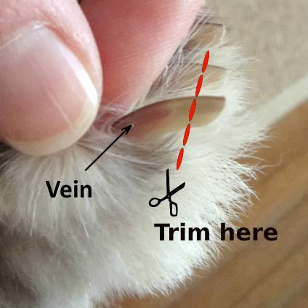
Please avoid the quick. In fact, don't even get close to it. You only want to trim the white or dark ends of each nail. Do very small trims — even if it is a half dozen or more each nail — until you can see the quick inside the nail.

