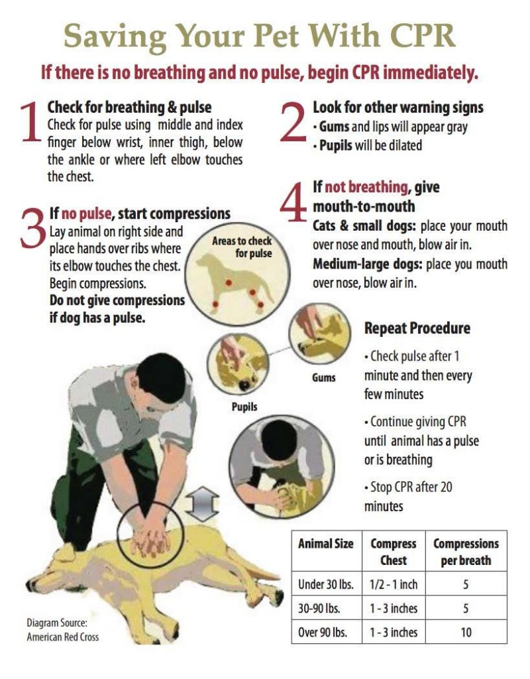

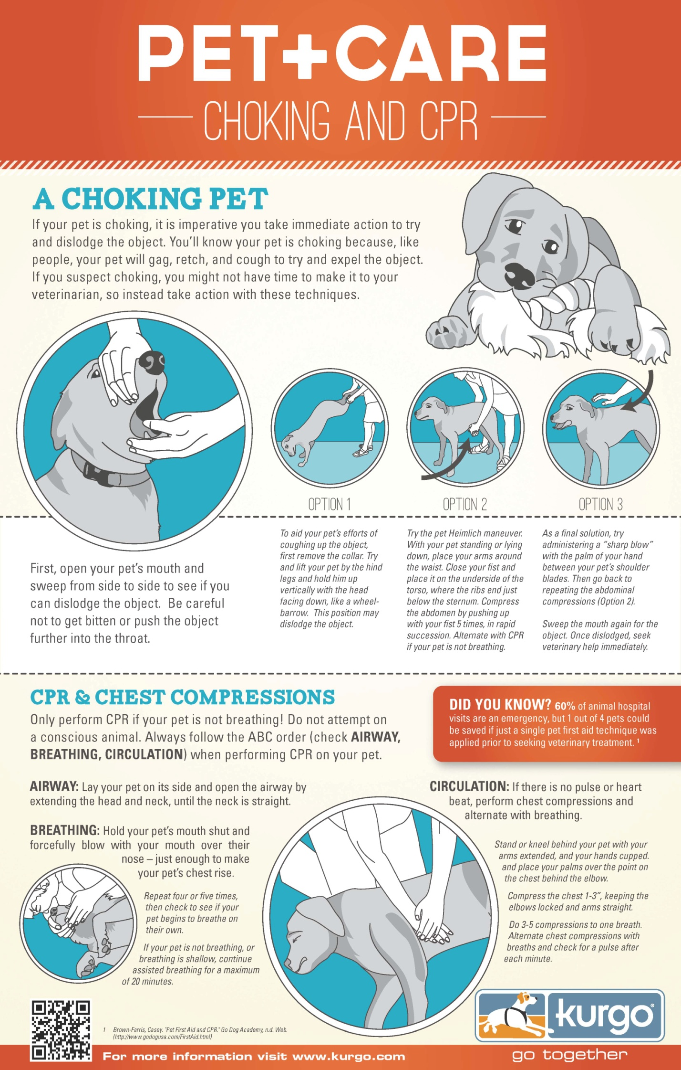
CPR for Dogs
Cardiopulmonary resuscitation, or CPR for dogs, is a combination of chest compression and artificial respiration. It is normally used when you cannot feel or hear the dog’s heartbeat. Once the dog stops breathing, the heart will go into cardiac arrest and cease beating.

Before performing CPR for dogs, please keep in mind that CPR is hazardous and can cause physical complications or fatal damage if performed on a healthy dog. Dog CPR should only be performed when necessary.

CPR for Puppies and Dogs Less Than 30 Pounds (14 kg):

- Lay the dog on a flat surface with his/her right side against the surface.
- Cup your palms and hold the dog with one palm on either side above the heart region. (You can also place your thumb on one side of the dog’s chest and keep the fingers on the other side.)
- Compress the chest one third to one half the width of the chest for a count of one, and then let go for a count of one. Carry on at a rate of 100-120 compressions in a minute.
- Close the muzzle with your hand before beginning artificial respiration. Give two breaths into the nose for every 10 to 15 compressions. It is best to have another person give the two breaths so compressions can continue during the breathing. A new person doing compressions should take over every two minutes or so to reduce the effect of fatigue.
- Continue with the CPR and artificial respiration for dogs until the dog begins breathing on its own and the pulse becomes steady.
- If the dog does not show any signs of improvement after 10 minutes of CPR, you can stop, as it has not proven successful.

CPR for Medium/Large Dogs Over 30 Pounds (14 kg):

- Lay the dog on a flat surface with his/her right side against the surface. (You will need to stand towards the dog’s back.)
- Place one of your palms on the dog’s rib cage, near the heart region, and put your other palm on top of it.
- Without bending your elbows, press the rib cage in a downward motion.
- Compress the chest one third to one half the width of the chest for a count of one, and then let go for a count of one. The rate should be 100-120 compressions per minute.
- Close the muzzle with your hand before beginning artificial respiration. Give two breaths into the nose for every 10 to 15 compressions. It is best to have another person give the two breaths so compressions can continue during the breathing. A new person doing compressions should take over every two minutes or so to reduce the effect of fatigue.
- Continue performing CPR and rescue breaths until the dog begins to breathe and has a steady pulse.
- If the dog does not show any signs of improvement after 10 minutes of CPR, you can stop, as it has not proven successful.

